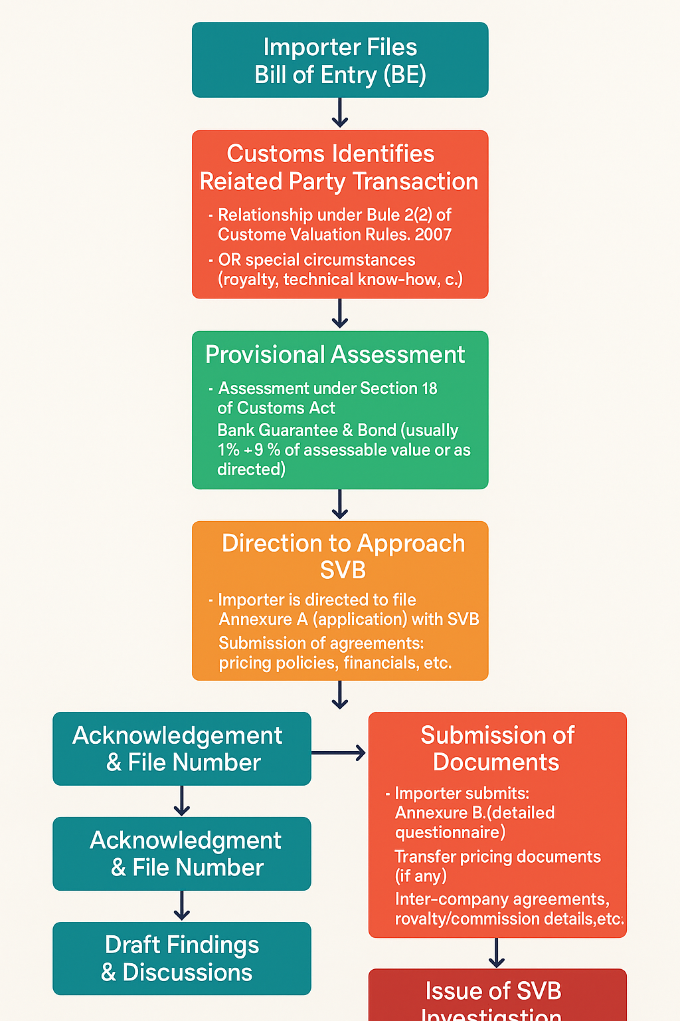

**FIGURE: SVB(Special Valuation Branch) PROCESS FLOW CHART**

This flowchart shows the **SVB (Special Valuation Branch) process** followed by Indian Customs when import transactions involve related parties or special circumstances. It ensures that the declared import values are fair and not manipulated due to related-party pricing or additional payments like royalties.